Latest Round-ups:
Season 2019/20
#18
Midweek Action: Nathan Ball had a night to remember between the sticks for Warminster, helping his side book a spot in the last eight of the Les Phillips Cup. Taking on an in-form Longwell Green outfit, Ball’s first big moment came during the first half, with the keeper scoring directly from a kick upfield, when the ball bounced over his opposite number. Jack Miluk was also on the scoresheet for the visitors, but Longwell Green fought back and sent the game to penalties thanks to goals from Eugene Keary and Sam Crumb. The spotlight then turned back on Ball, and he stepped up, saving three spot kicks, before then firing home the winner from 12 yards to complete an incredible individual performance. In Tuesday’s other second round tie, Sacha Tong struck the winner 13 minutes from time to help Hallen defeat Street 2-1.
FA Vase: Bradford Town booked their spot in fourth round following a dramatic extra-time victory over Bridgwater Town. In what started out as a tight affair, the Bobcats took until 62 minutes to break the deadlock, with Gary Higdon heading home a Matt Morris cross. Bridgwater weren’t there to make up the numbers however, and having been behind for less than ten minutes, they got back on level terms with Mr Reliable, Jake Llewellyn tucking home his penalty. With the extra-time period less than three minutes old, Bradford went ahead for the second time in the contest through Sean Keet. A frantic 30 minutes then ensued, with Harry Horton volleying the visitors level, before Tyson Pollard restored Bradford’s advantage from the spot. Jack Witcombe was then sent off for the home side just before half-time of extra-time, with Pollard then scoring for the ten men to give them their first two-goal lead of the afternoon. That second Pollard strike proved crucial, after Tom Ellis headed home for Bridgwater who fell one goal short of a last-ditch comeback. In another incident-filled clash, nine-man Buckland held off a late charge from ten-man Tavistock to prevail by two goals to one in Devon. Tavistock made a really poor start to the contest, and after Tom Strike was awarded an early red card, they then fell two goals behind with Richard Groves and Mani Skett scoring in quick succession. A flash point at the beginning of the second half threatened Buckland’s position of strength, with Dan Harrison dismissed for a foul in the area which led to a penalty for the home side. Jack Crago saw his spot kick saved by Ken Griffiths however to maintain his side’s two-goal advantage. With 20 minutes left on the clock, Lloyd Gardner joined Harrison in getting an early bath, and Tavistock set up a nail-biting final few minutes when Jordan Annear pulled a goal back. The hosts pushed hard in the closing stages, but they were unable to force home an equaliser, giving Buckland a memorable victory.
In the other all-Western League tie on Saturday afternoon, Bitton defeated Cribbs 2-1 to extend their run in the competition. Having taken a 15th minute lead through Josh Egan, Bitton were hauled back by their visitors who levelled affairs through George Kellow following a fine set-piece delivery from Jacob Hodgson. The game was decided just prior to the hour mark, with Ryan Bath popping up in the right spot to slot home the winner. The star of the day in the FA Vase was Plymouth Parkway’s Jordan Copp, who scored all of his side’s goals during a 4-1 victory away at Hamworthy United. After Copp had given Parkway a fifth minute lead, the Hammers responded to make it 1-1 towards the end of the first half. After the interval, Copp was unstoppable, firstly restoring Parkway’s lead, before then curling home a terrific effort from outside the box to complete his hat-trick. With less than five minutes left on the clock, Copp added some gloss to the scoreline, slotting home his fourth of the game to wrap up a terrific win for the in-form Devonians. On Sunday, Warminster knocked out Premier Division outfit Roman Glass St George with a come from behind 2-1 victory. After falling behind to George Box’s early opener, Eben Mortimer-Taylor levelled for Warminster at the end of the first half, before James Vincent struck late on to book the Wiltshire side’s spot in the last 32.
Premier Division: Hallen have now won four league games on the bounce thanks to a last-gasp 3-2 victory away at Chipping Sodbury Town. After taking a very early lead through Sacha Tong, Hallen conceded either side of the interval to trail going into the final half-hour. They were handed a lifeline when Kyle Thomas slotted home the equalising penalty, and then in injury-time, Hallen managed to beat their ten-man hosts when Isaac Reid scored the game-winner. Bridport were the last time to beat Hallen in the league, and they moved up to 18th on Saturday afternoon, after second half goals from Declan Cornish and Tom Richardson handed them a 2-0 victory at home to Cadbury Heath. Another team to win by two goals to nil were Clevedon Town, with a pair of second half strikes helping them see off Westbury at the Hand Stadium. Morgan Williams headed Clevedon in front on the hour mark thanks to a fine cross from George King, with Lucas Vowles then wrapping up the victory to help his side rise up to fourth. Just one place lower on the table are Exmouth, who collected their ninth league victory of the season thanks to a 2-1 triumph at home to Shepton Mallet. Goals either side of the break from Ben Steer and Jordan Harris proved to be enough for Exmouth, who were given a late scare when Jacob Lyons headed home for the visitors during the final 20 minutes. Keynsham Town ended a five-match losing run by sneaking to a 1-0 victory away at free-falling Odd Down. With neither side bringing any semblance of form into the contest, it was no surprise that one goal was all that separated the sides, with Stefan Lee’s 62nd minute effort handing the K’s all three points. Brislington were denied victory late on during their clash at home to Street, with the visitors bagging a late point to end their two-match losing run. After Neikell Plummer had put the hosts within sight of anther home win, Olly Hebbard stepped up to equalise with 11 minutes left on the clock.
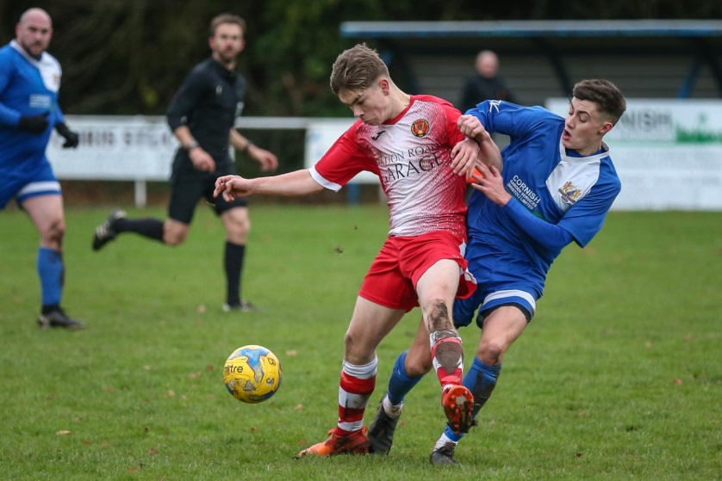
First Division: In a top-three battle, Calne Town eventually wore down their undermanned hosts to claim a 2-1 victory over Sherborne. The Zebras suffered a big blow at the end of the first half when Matt Brown was given a straight red card, but they managed to regroup and forged ahead through Ashley Clarke soon after the interval. With a famous victory in sight, Sherborne hearts were broken by Stuart Windsor who headed home an 88th minute equaliser, with the ten men then unable to regroup in time before Zak Mitchell scored less than two minutes later to complete Calne’s late snatch-and-grab. In one of the craziest games of the season so far, Oldland Abbotonians scored three times in the final ten minutes to come from behind and secure a 4-3 victory away at Almondsbury. Having taken a 13th minute lead through Cash Vinall, Oldland capitulated at the end of the first half, with Stuart Alexander, Geraint Williams and Matthew Davies all finding the back of the net in a five-minute spell. Vinall’s 80th minute penalty gave Oldland hope going into the closing stages, and they then got on level terms two minutes from time when a cross from Antonio Nurse deflected in off an Almondsbury defender. Having played a big part in the equaliser, Nurse then fired home the seventh and final goal of the contest, playing a one-two with Frank Taylor-Fox, before converting the stoppage-time winner to cap a thrilling contest. Cheddar couldn’t quite replicate Oldland’s come-from-behind victory, but after falling to a three-goal deficit inside 20 minutes they will be pleased to have survived with a 3-3 draw at home to Ashton & Backwell United. In what was a stunning start to the game, Miles Hardidge curled Ashton into a 7th minute lead, before Calum Townsend’s left-footed finish doubled their advantage. The visitors then managed to extend their lead to three, when Joe Bishop was afforded the chance to score with a rebound after his original penalty had been kept out by Tom Creed in the Cheddar net. All the goalscoring action at Bowdens Park occurred before the interval, with Rick Bennett capitalising on an error by the visiting keeper to get his side on the board. Bennett then scored a wind-assisted second six minutes before half-time, with George Booth then sliding the ball home in stoppage time to end a wild opening 45. Another standout individual performance from Lewis McCarron helped Corsham come from behind to beat Bishop Sutton 2-1 at Lakeview. Following a 23rd minute opener from the hosts, Corsham managed to get back on level terms before the break, with McCarron’s pinpoint corner flicked home by Nick Chandler. Seven minutes into the second half, McCarron got the goal his performance deserved, with the forward stabbing home from close range thanks to a pull-back from Josh Bright.
Players battle for possession during Corsham’s 2-1 win over Bishop Sutton. Image courtesy of John Cuthbertson.
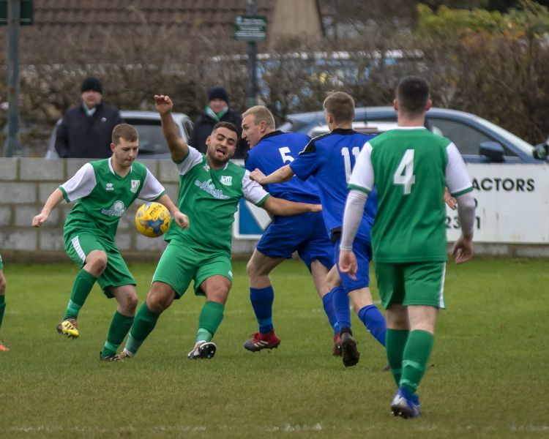
Longwell Green Sports continue to impress, and the second-place side scored three times in either half to secure a 6-0 win away at Lebeq United. Kyle Box bagged a brace during the victory, with Sam Crumb, Eugene Keary, Luke Bryan and Connor Britton all on target at Oaklands Park. Another big winner were Wells City, for whom leading scorer Harry Foster played a starring role once more during their 5-1 victory away at Bristol Telephones. With Harvey Hadrill having put Wells ahead in the opening minutes, Foster had his first major impact on the game after quarter of an hour when his volley doubled the visitors tally. A long range effort from Foster extended Wells’ lead to three, before the Phones pulled a goal back from the spot through Dawid Regula. Wells hit back instantly, with Craig Herrod restoring their three-goal advantage, before Foster provided the assist for Steve Sokol to put a cap on the scoring 11 minutes from time. Radstock Town pulled off an impressive 4-0 win away at Wincanton, scoring three times in the opening quarter to stun their top six rivals. The visitors shot out of the blocks, and after Simon Millard had handed them a 13th minute lead, Rico Sobers then pounced to double their tally five minutes later. Jack Biddiscombe added a third for the Miners midway through the first half, with Morgan Skipp completing the scoring on the hour mark to make it three away wins on the bounce. Welton Rovers ended November on a high, overturning an early deficit to beat Devizes 2-1 at West Clewes. It was Town who made the early running, and they went ahead in the 7th minute through Chris Allen, before Welton responded in quick fashion, with Lewis Coleman claiming the equaliser within ten minutes of falling behind. The winning goal then came 15 minutes into the second half, with Dylan Hatt scoring from a near-impossible angle, thanks to a finish which deflected in off the crossbar. In another bottom half clash, Ben Hebditch managed to grab an equaliser for Bishops Lydeard during their 1-1 draw with Portishead Town at Cothelstone Road.
Action from the clash between Welton and Devizes at West Clewes, courtesy of Martin Pearce.

Volunteers
The Toolstation Western League recognises the value of volunteers in running and developing football at every level.
Volunteers are the backbone of grassroots football. Without the time, dedication and commitment volunteers demonstrate each and every week clubs and leagues would simply not exist. A football club or league is about more than just the players on the pitch.
Clubs in the Western League require a varied number of volunteers to fulfil important roles to help them operate and develop. From turnstile operators, PA announcers and serving refreshments to pitch maintenance and general tidying up of the ground.
You can help your local club by becoming part of the Western League ‘Family’ and ensuring that clubs continue to grow and thrive for the benefit of the whole community. Take a look at what volunteer roles need filling at your local club below.
If your club has not listed any volunteer jobs yet, why not contact them directly? You will find their contact details on the individual club pages.

Devizes Town - Nursteed Road, Devizes SN10 3DX
The club has the following roles to cover:
- Half time hospitality
- Marking of the pitch
- Kit manager
- General duties of cleaning up before and after games
- After match food catering
Anyone interested in volunteering at Devizes Town Football Club should email Club Secretary Neil Fautley: neil@marketplaceflooringltd.co.uk

Oldland Abbotonians - Aitchison Playing Field, Castle Road, Oldland Common BS30 9SZ
The club has the following roles to cover:
- Gate person
- Volunteer bar staff (Midweek/Friday night/Sunday all day - but Saturday helpers also considered)
- PA announcer
- Programme Editor
- Website Editor
- Matchday ground staff – nets, stands, dugouts (before and after games)
Anyone interested in volunteering at Oldland Abbotonians Football Club should email Chairman Derek Jones -chairman@oldlandfootball.com or Telephone: 07836 648327

Wells City - Athletic Ground, Rowdens Road, Wells BA5 1TU
The club has the following roles to cover:
- Hospitality
- Gate Office
- Raffle seller
- PA announcer
- Photographer
Anyone interested in volunteering at Wells City Football Club should email Club Secretary Dave Green -daveg55@hotmail.co.uk or Telephone: 07584 045238

Western League Statistical Leaders

PREMIER DIVISION LEADING GOAL SCORERS (League only):
Adam Carter (Plymouth Parkway) – 20
Lucas Vowles (Clevedon Town) – 12
Gary Higdon (Bradford Town) – 11

PREMIER DIVISION TOP ATTENDANCES:
Bridport 0 Bridgwater Town 6, Sunday 6th October 2019 – 347
Wellington 0 Exmouth Town 2, Sunday 6th October 2019 - 315
Plymouth Parkway 1 Exmouth Town 0, Wednesday 21st August 2019 - 308

FIRST DIVISION LEADING GOAL SCORERS (League only):
James Rustell (Radstock Town) – 16
Harry Foster (Wells City) – 14
Stuart Windsor (Calne Town) – 12
Adam Wright (Cheddar) – 10
Danny Carter (Longwell Green Sports) – 10
Toby Cole (Wincanton Town) - 10

FIRST DIVISION TOP ATTENDANCES:
Warminster Town 2 Bristol Telephones 3, Saturday 5th October - 369
Portishead Town 3 Longwell Green Sports 5, Saturday 5th October – 262
Devizes Town 0 Ashton & Backwell United 1, Saturday 5th October – 252

LEADING SCORERS IN ALL COMPETITIONS:
Jack Crago (Tavistock) - 25
James Rustell (Radstock Town) – 21
Adam Carter (Plymouth Parkway) – 20
Harry Foster (Wells City) – 19
Gary Higdon (Bradford Town) – 18
Jack Taylor (Bridgwater Town) – 16

*All goalscoring stats via Full-Time FA website

Be sure to check out the latest podcast, where Ian, Tom & guests recap all the latest news and results from around the Western League. To follow along all season, each broadcast will be available at the following link: http://www.toolstationleague.com/podcasts.php

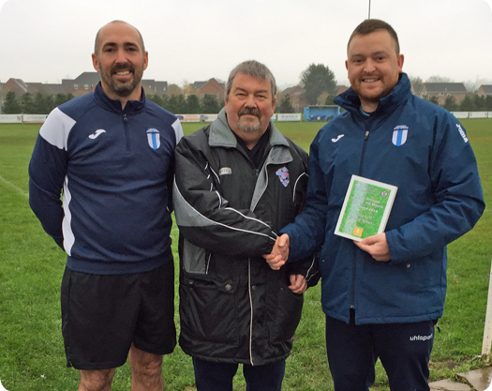
Awards Update
Longwell Green Sports duo Mitch Hodge and Scott Woodman are presented with the First Division Team of the Month Award for October by League Secretary Andy Radford.

Latest Results
Tuesday 26th November 2019
Les Phillips Cup – Second Round
Hallen 2-1 Street 61
Longwell Green Sports 2-2 (3-4 pens) Warminster Town 40
Saturday 30th November 2019
FA Vase – Third Round
Bitton 2-1 Cribbs 70
Bradford Town 4-3 AET Bridgwater Town 148
Hamworthy United 1-4 Plymouth Parkway
Tavistock 1-2 Buckland Athletic 105
Premier Division
Bridport 2-0 Cadbury Heath 89
Brislington 1-1 Street 52
Chipping Sodbury Town 2-3 Hallen 76
Clevedon Town 2-0 Westbury United 70
Exmouth Town 2-1 Shepton Mallet 171
Odd Down 0-1 Keynsham Town 43
First Division
Almondsbury 3-4 Oldland Abbotonians 23
Bishop Sutton 1-2 Corsham Town 39
Bishops Lydeard 1-1 Portishead Town
Bristol Telephones 1-5 Wells City 27
Cheddar 3-3 Ashton & Backwell United 67
Lebeq United 0-6 Longwell Green Sports 20
Sherborne Town 1-2 Calne Town 106
Welton Rovers 2-1 Devizes Town 72
Wincanton Town 0-4 Radstock Town 41
Sunday 1st December 2019
FA Vase – Third Round
Roman Glass St George 1-2 Warminster Town 140
Upcoming Fixtures
Tuesday 3rd December 2019
Premier Division
Bridgwater Town vs Keynsham Town 19:45KO
Odd Down vs Chipping Sodbury Town 19:45KO
Shepton Mallet vs Buckland Athletic 19:30KO
First Division
Longwell Green Sports vs Hengrove Athletic 19:30KO
Dorset FA Senior Cup – Quarter Final
Verwood Town vs Bridport 19:30KO
Wednesday 4th December 2019
Premier Division
Cadbury Heath vs Roman Glass St George 19:30KO
First Division
Oldland Abbotonians vs Portishead Town 19:45KO
Warminster Town vs Cheddar 19:45KO
Les Phillips Cup – First Round
Exmouth Town vs Plymouth Parkway 19:30KO
Wiltshire FA Premier Shield – Quarter Final
Bradford Town vs Swindon Supermarine 19:30KO
Westbury United vs Swindon Town 19:45KO
Friday 6th December 2019
First Division
Radstock Town vs Bishop Sutton 19:30KO
Saturday 7th December 2019 (KICK OFF AT 3.00PM UNLESS NOTED)
Premier Division
Brislington vs Tavistock
Buckland Athletic vs Bradford Town
Chipping Sodbury Town vs Street
Cribbs vs Clevedon Town
Exmouth Town vs Hallen
Keynsham Town vs Bridgwater Town
Plymouth Parkway vs Bridport
Roman Glass St George vs Bitton
Wellington vs Shepton Mallet
Westbury United vs Cadbury Heath
First Division
Ashton & Backwell United vs Calne Town
Corsham Town vs Cheddar
Devizes Town vs Bristol Telephones
Hengrove Athletic vs Warminster Town
Portishead Town vs Lebeq United
Sherborne Town vs Longwell Green Sports
Welton Rovers vs Almondsbury
Wincanton Town vs Bishops Lydeard

League Tables
Premier Division
 |  | P | W | D | L | F | A | GD | PTS
1 | Bradford Town | 14 | 12 | 1 | 1 | 46 | 14 | 32 | 37
2 | Plymouth Parkway | 13 | 11 | 1 | 1 | 54 | 13 | 41 | 34
3 | Hallen | 15 | 9 | 2 | 4 | 32 | 27 | 5 | 29
4 | Clevedon Town | 16 | 9 | 2 | 5 | 36 | 33 | 3 | 29
5 | Exmouth Town | 11 | 9 | 0 | 2 | 29 | 7 | 22 | 27
6 | Bridgwater Town | 14 | 8 | 3 | 3 | 42 | 21 | 21 | 27
7 | Brislington | 19 | 8 | 3 | 8 | 30 | 43 | -13 | 27
8 | Bitton | 13 | 8 | 0 | 5 | 38 | 22 | 16 | 24
9 | Westbury United | 16 | 7 | 3 | 6 | 33 | 25 | 8 | 24
10 | Buckland Athletic | 13 | 7 | 1 | 5 | 23 | 22 | 1 | 22
11 | Tavistock | 11 | 6 | 2 | 3 | 28 | 16 | 12 | 20
12 | Shepton Mallet | 13 | 6 | 2 | 5 | 23 | 22 | 1 | 20
13 | Street | 16 | 6 | 2 | 8 | 34 | 38 | -4 | 20
14 | Cribbs | 16 | 6 | 2 | 8 | 26 | 35 | -9 | 20
15 | Keynsham Town | 15 | 5 | 2 | 8 | 29 | 38 | -9 | 17
16 | Cadbury Heath | 17 | 3 | 6 | 8 | 22 | 37 | -15 | 15
17 | Roman Glass St George | 12 | 4 | 2 | 6 | 29 | 17 | 12 | 14
18 | Bridport | 18 | 4 | 1 | 13 | 23 | 61 | -38 | 13
19 | Odd Down | 15 | 3 | 1 | 11 | 14 | 36 | -22 | 10
20 | Wellington | 17 | 3 | 1 | 13 | 17 | 43 | -26 | 10
21 | Chipping Sodbury Town | 16 | 2 | 1 | 13 | 17 | 55 | -38 | 7

First Division
 |  | P | W | D | L | F | A | GD | PTS
1 | Calne Town | 15 | 10 | 2 | 3 | 24 | 9 | 15 | 32
2 | Longwell Green Sports | 14 | 10 | 1 | 3 | 37 | 20 | 17 | 31
3 | Sherborne Town | 14 | 9 | 0 | 5 | 31 | 21 | 10 | 27
4 | Wincanton Town | 13 | 8 | 2 | 3 | 28 | 23 | 5 | 26
5 | Wells City | 14 | 7 | 4 | 3 | 35 | 20 | 15 | 25
6 | Radstock Town | 13 | 8 | 1 | 4 | 34 | 22 | 12 | 25
7 | Cheddar | 14 | 7 | 3 | 4 | 28 | 22 | 6 | 24
8 | Ashton & Backwell United | 15 | 6 | 5 | 4 | 23 | 28 | -5 | 23
9 | Oldland Abbotonians | 14 | 6 | 4 | 4 | 18 | 21 | -3 | 22
10 | Corsham Town | 16 | 7 | 1 | 8 | 28 | 41 | -13 | 22
11 | Lebeq United | 15 | 7 | 0 | 8 | 31 | 33 | -2 | 21
12 | Warminster Town | 13 | 6 | 0 | 7 | 27 | 18 | 9 | 18
13 | Welton Rovers | 15 | 5 | 3 | 7 | 19 | 28 | -9 | 18
14 | Bishops Lydeard | 13 | 5 | 2 | 6 | 25 | 23 | 2 | 17
15 | Almondsbury | 14 | 5 | 2 | 7 | 23 | 28 | -5 | 17
16 | Portishead Town | 12 | 4 | 2 | 6 | 27 | 25 | 2 | 14
17 | Devizes Town | 12 | 2 | 4 | 6 | 22 | 24 | -2 | 10
18 | Hengrove Athletic | 13 | 2 | 4 | 7 | 7 | 31 | -24 | 10
19 | Bishop Sutton | 13 | 2 | 2 | 9 | 17 | 25 | -8 | 8
20 | Bristol Telephones | 16 | 1 | 2 | 13 | 19 | 41 | -22 | 5

